**Jeremy Rios-Martinez**

**COMSC 265**

**Lab 56**

Screen Print out of exercise 1

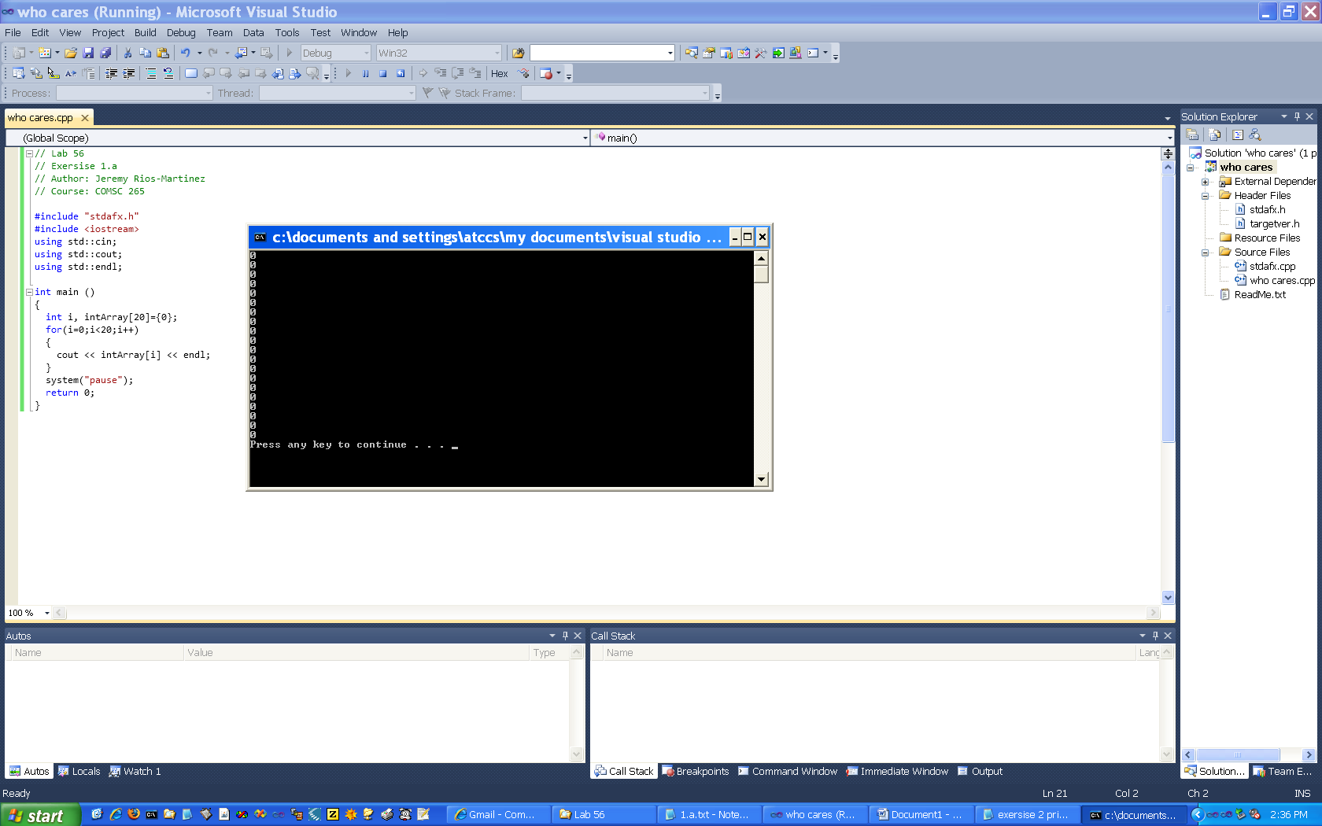

Screen Print out of exercise 2

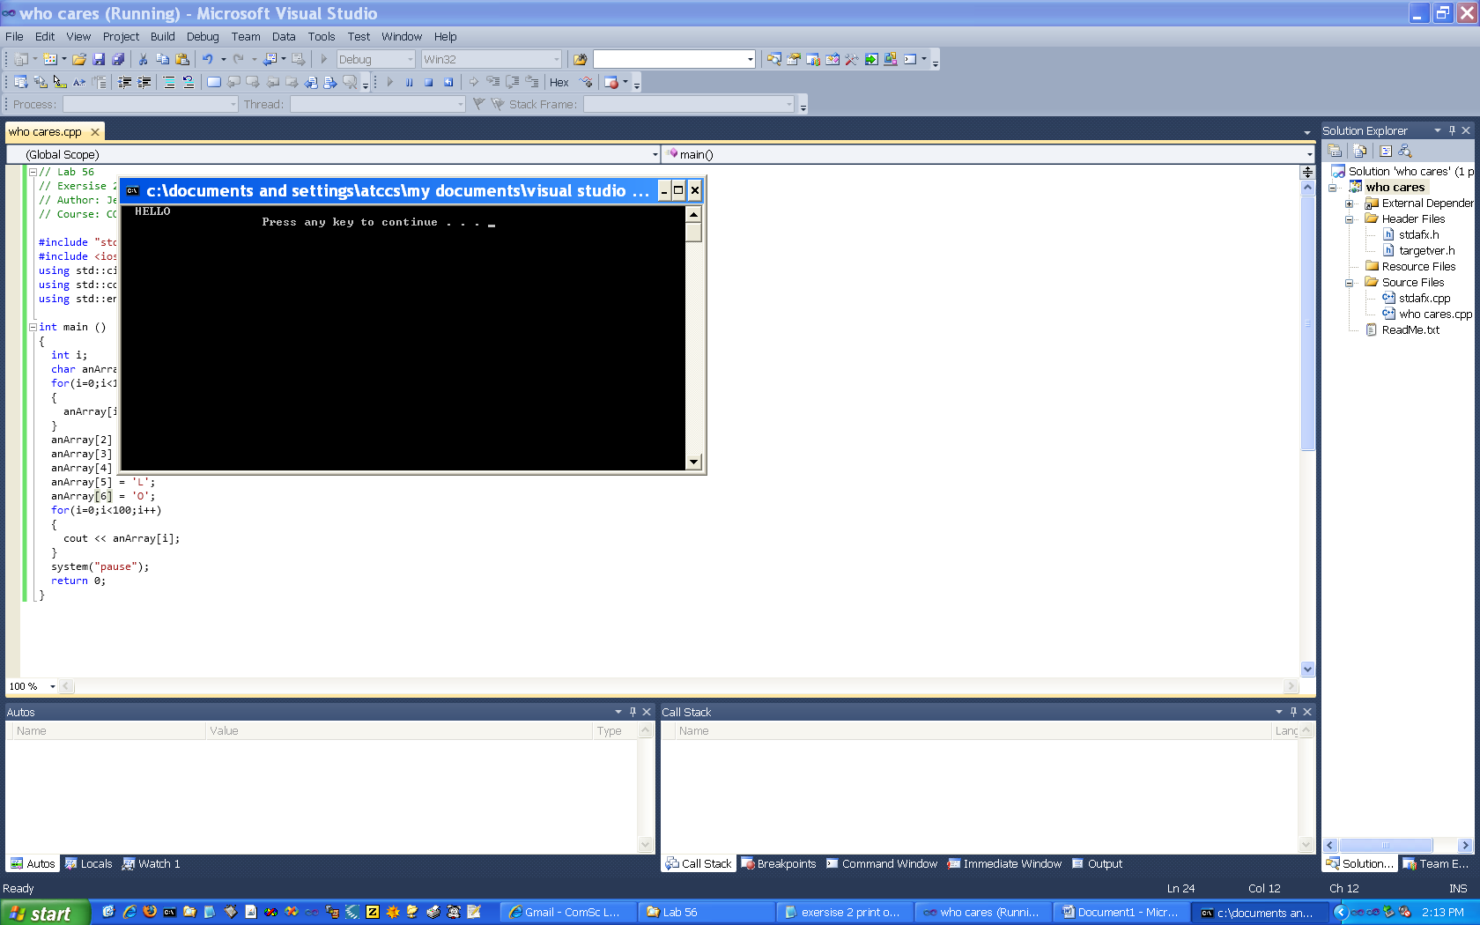

Screen Print out of exercise 3

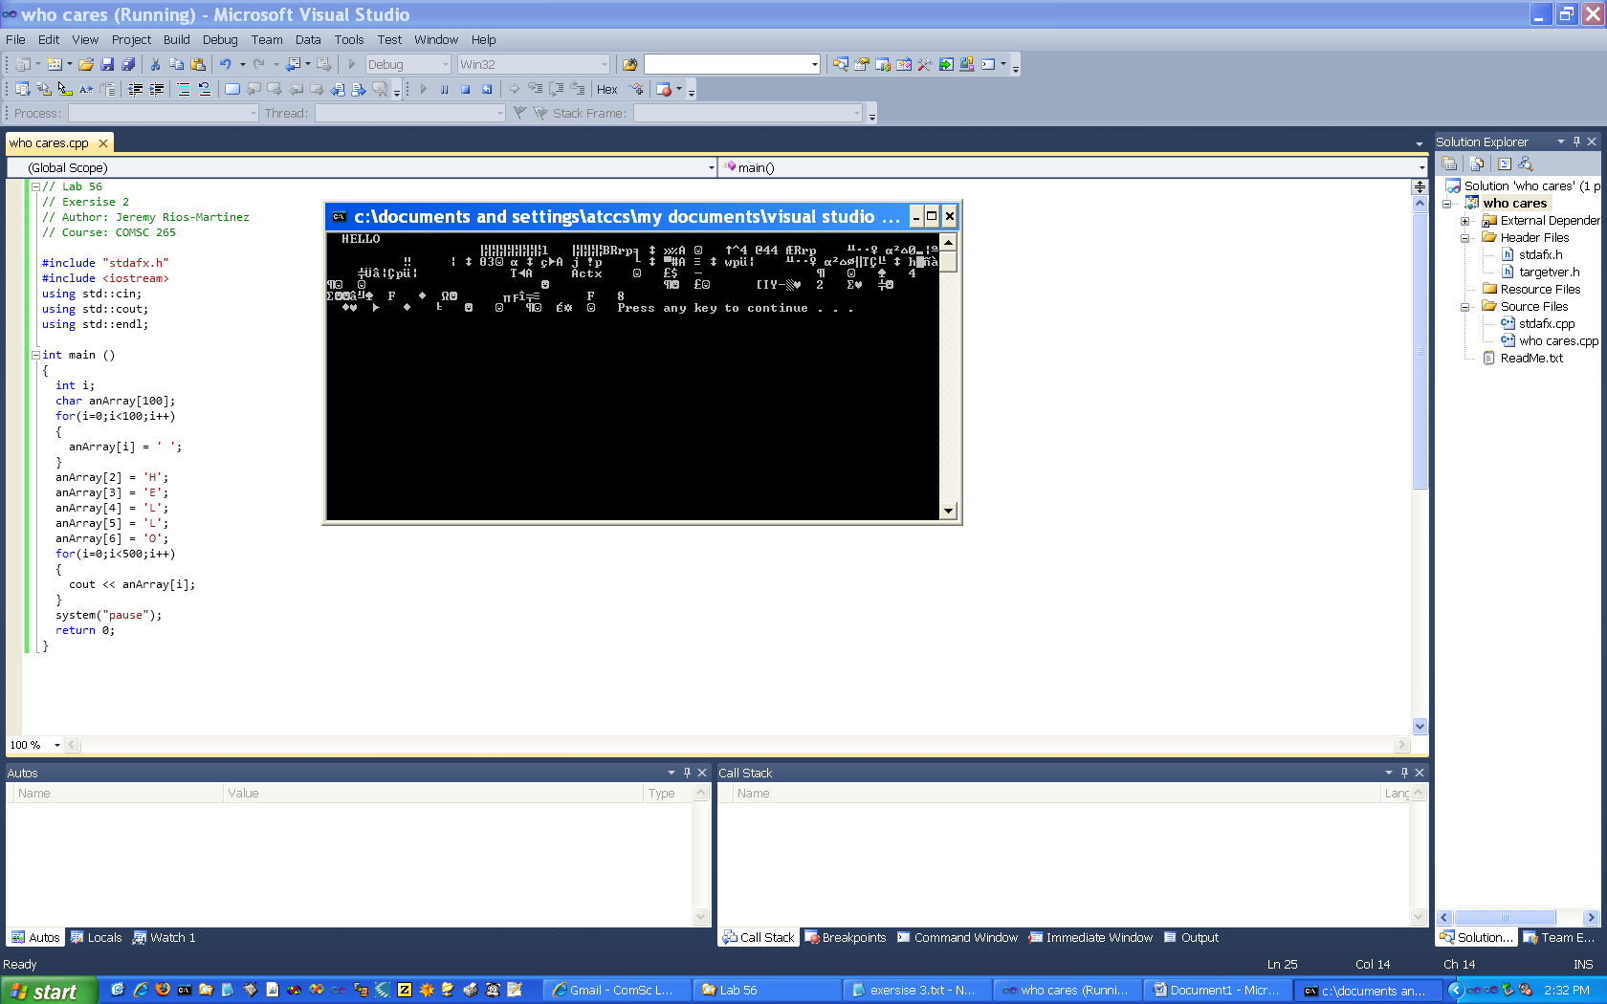

Screen Print out of exercise 4

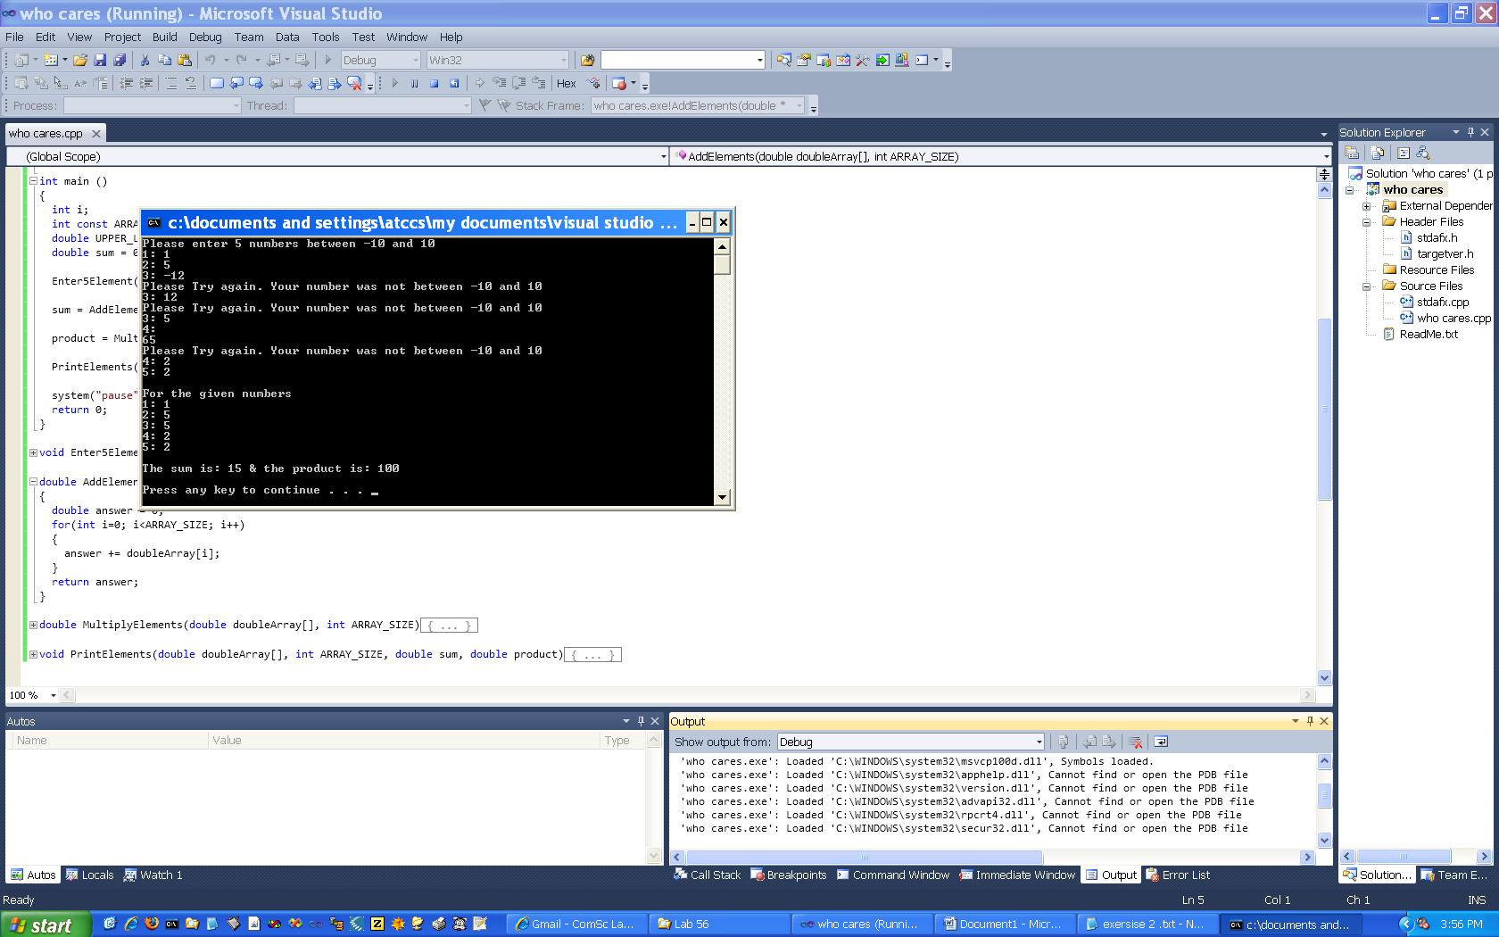

Screen Print out of exercise 5

